## Home Work Task1:

Create CV pages markup. It should be a simple pages **without** styles (backgrounds, colors, etc.) but logical contains frames and margins, positions, paddings);

Use:

HTML5 – DOCTYPE; Add HTML5 tags;

**!! Markup should implement according to the semantics!!**

## The criteria for evaluation:

1) Create standards-compliant HTML document for two files pages that we will use in the future (index.html and inner.html). Use semantic elements artcle, footer, nav, header, form, fieldset, etc. (1 point)

2)Use the proper document structure (nesting of elements, commetns). Clearly define content for the elements. (1 point)

3) Separate the content html from style. Create all.css file. Did not use inline styles in the HTML; (1 point)

4) In case when removed linked css files from section <head> in the HTML document. The document must be readable and well-structured, nothing should fall or break. Please have a look for pictures below (1 point):

index.html

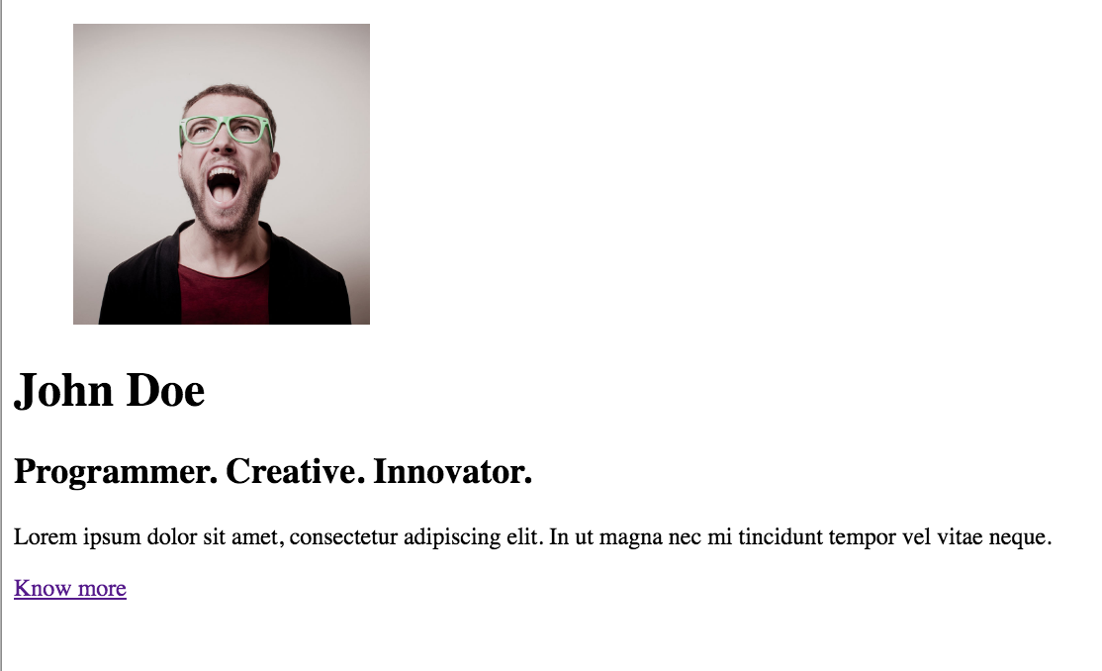

inner.html

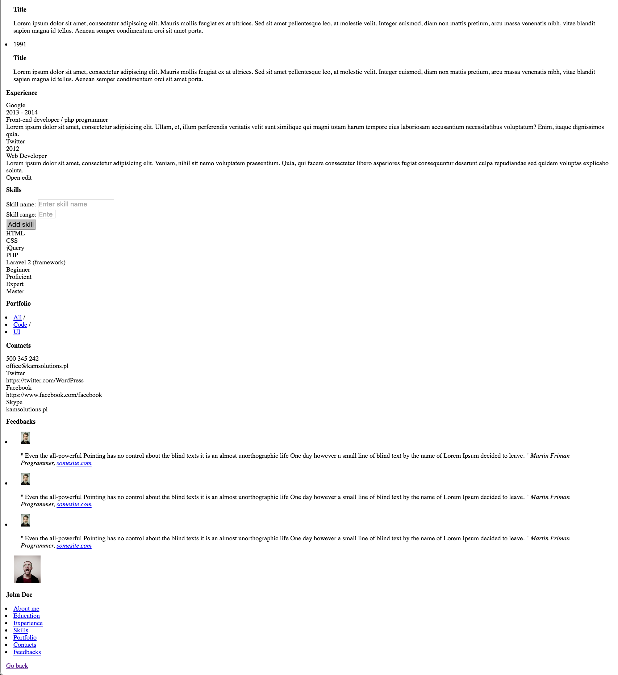

5) Implement positions for element:

- floats,

- clearfix,

- positions.

In this case red lines show the element layout (you can add style in css for particular element : border 1px solid #f00;) – show independent blocks in the document; For correct (sizes, paddings, margins) please look for the materials folder. (2 points). Have a look – “helpers_pictures” folder.

6) On the first page (index.html). Block that contains user photo and login form should be always horizontaly and vertically centered. (1 point)

7) Please create flexible width for the content side on the second page; (Please see CV_new.mp4 from materials folder); (2 point)

8) Documents HTML - must be inspected by the validator. (1 point)

WCAG 1.0 (A) use the resource for this test - <https://achecker.ca/checker/>

or [www.totalvalidator.com](http://www.totalvalidator.com)

In the settings choose the type of accessibility checking:

Guidelines to Check Against

WCAG 1.0 (Level A)

As the result - Accessibility Review report in success state;

<http://en.wikipedia.org/wiki/Web_Content_Accessibility_Guidelines>

Maximum – **10** points for this Module!

## References:

- You may use different images for photos in the design.

- Use this project files structure:

markup

|

├── css

|

all.css

├── fonts

├── images

├── index.html

├── inner.html

├── js

* guideline.jpg – will help you with styles and margins;